3 June
EPS Lawrence editing log
Adding new data to indst BPE CO₂ NO₂ CH₄
Table 4-2 Hong Kong’s Emissions of Carbon Dioxide, Methane and Nitrous Oxide in 2018 (kt) https://unfccc.int/sites/default/files/resource/China_BUR3_English.pdf

Updated the land use BLAPE
Table 4-2 Hong Kong’s Emissions of Carbon Dioxide, Methane and Nitrous Oxide in 2018 (kt) https://unfccc.int/sites/default/files/resource/China_BUR3_English.pdf

5 June
Policy scenario
Reduce waste emission to zero – changed traction of methane capture opportunities achieved to 1
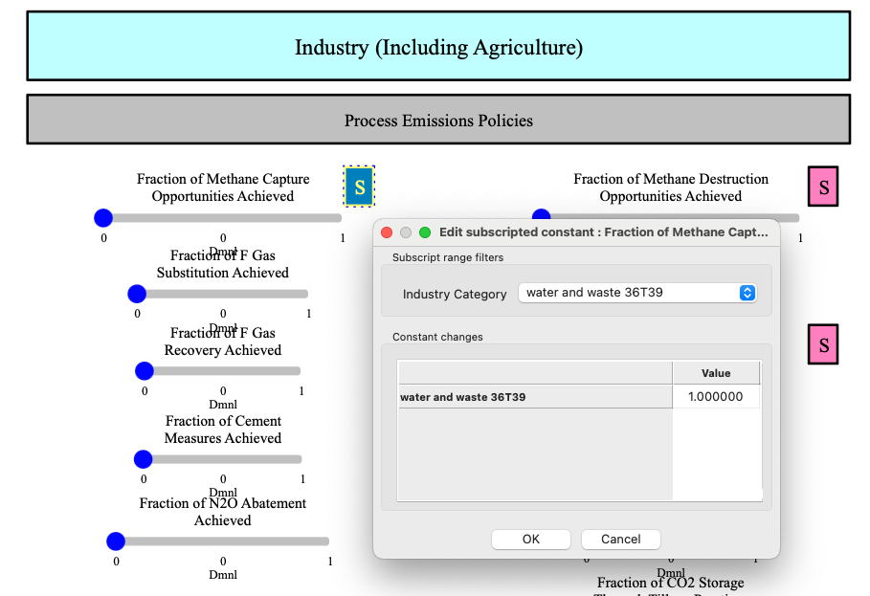

BCEU – updated the commercial sector
Emission reduced
Time (Year) New | 2021 | 2022 | 2023 | 2024
Output Total CO2e Emissions : MostRecentRun | 36.2991 | 36.0299 | 36.6369 | 36.2106
Time (Year) Old | 2021 | 2022 | 2023 | 2024
Output Total CO2e Emissions : MostRecentRun | 37.5568 | 37.649 | 38.2789 | 37.8032

BCEU – updating residential
On Future endues share
7 June
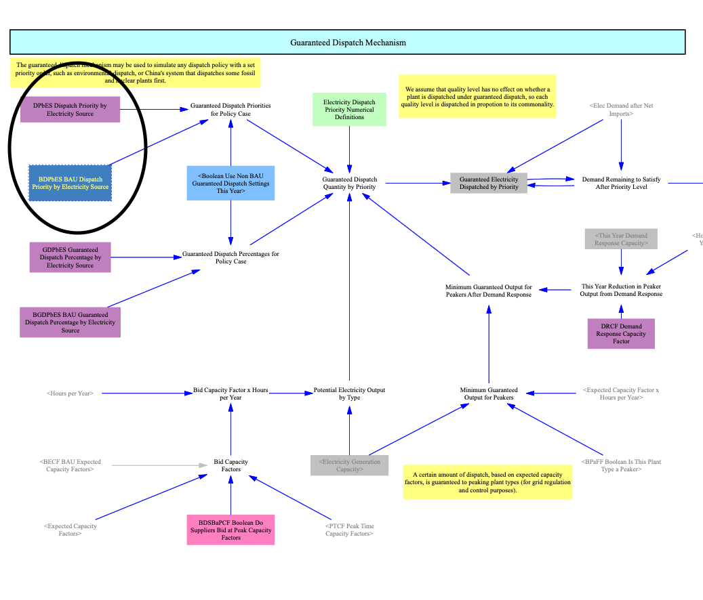
Adjusted GDPBES and BGDPbES
Need to work on this
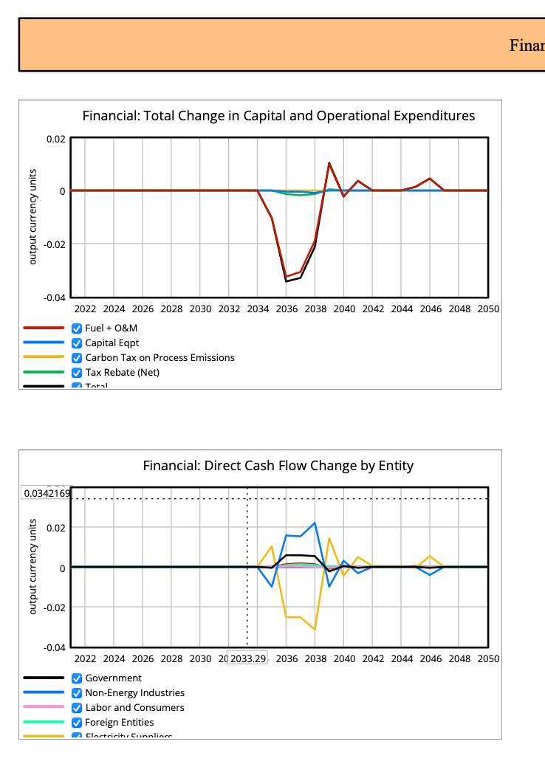
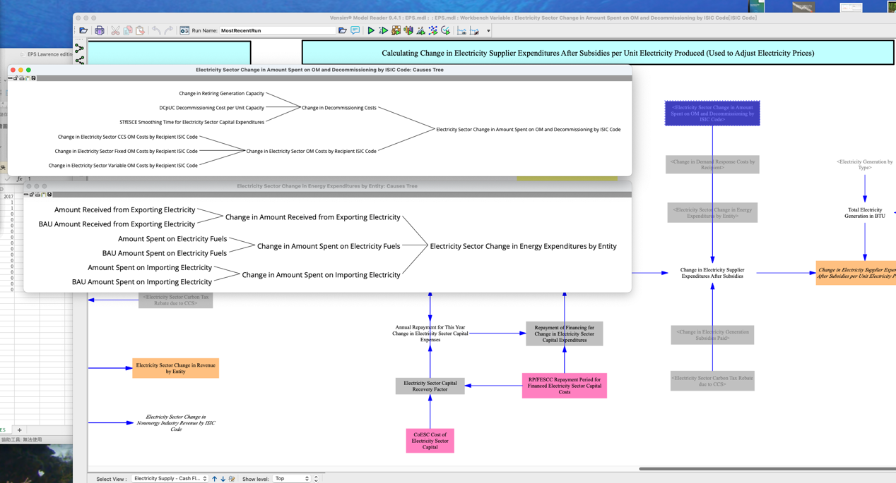

13 June
Updated 3.4.9
Updated trans/ BCDTRtSY
Updated trans/ BESP – after 2025 PV subsidy =0
Updated BFPaT electricity –
100 kwh = HK$198.92 = US$25.5
100 kwh = 341214 BTU
25.5/341214 = 7.47407E-05
Tariff increase 2% P/A

BFPaT- pre tax – petgas Gasoline
=(20-6.82)/7.8/30140
Est 2050 HK$30 / L
Updated BRZSPbS

Updated BVTQaZ – after 2035 plug in hybrid not as a NEV
